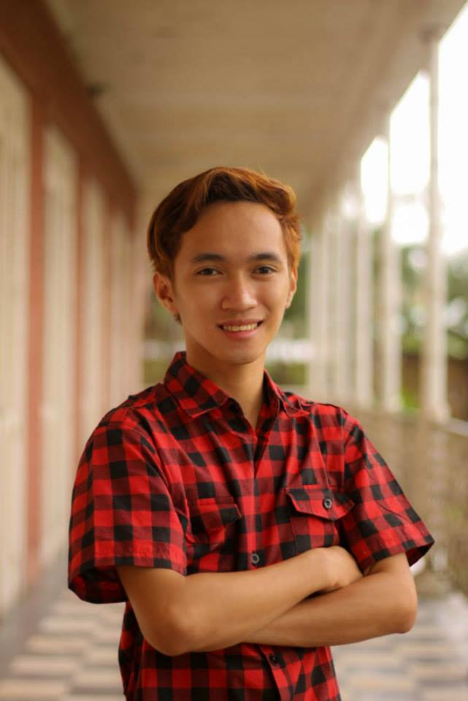

**KIM MERVIN GUARDIANO LABAGALA**

1137 Calachuchi St. corner 5th St.,

Bgy. Muñoz, Catbalogan City, Samar

+(63)9272925291 (Phone)

[kim201051537@gmail.com](mailto:kim201051537@gmail.com) E-mail

**EDUCATIONAL BACKGROUND:**

Tertiary Education **University of the Philippines Visayas – Tacloban College**

Tacloban City

**Bachelor of Arts in Communication Arts**

2010 – 2014

**University of the Philippines Diliman**

Quezon City

Cross-enrollee

Summer AY 2011-2012

Secondary Education **Samar College**

Catbalogan City

2006 – 2010

Primary Education **Saint Mary’s Child Development Center**

1st Honorable Mention

Catbalogan City

2001 – 2006

**Catbaogan III Central School**

Catbalogan City

2000 – 2001

Thesis Title: **Visual Semiotic Analysis of Iconic Typhoon Haiyan Photographs**

**WORK EXPERIENCE/QUALIFICATIONS:**

Councilor, **Sangguniang Kabataan,** 2010-2013

Tutor, **Brainbox Tutorial Services,** 2011-2012

Organizer, **7th Largabista Film Festival,** February 2013

Intern, **Association for the Rights of Children in Southeast Asia (ARCSEA)**, April-May 2013

Volunteer, **Salinlahi Alliance for Children’s Concerns,** June-July 2014

Passer, **Civil Service Commission Professional Eligibility Examination,** April 2014

**SEMINARS AND TRAINING EXPERIENCES:**

**UP units GT Summit & Leadership Training (2012 & 2014)**

May 2012, Dive & Trek Resort, Anilao, Batangas

June 2014, Redwood Villas, Clark, Angeles City, Pampanga

**Basic Advertising Orientation**

February 2013, Campaigns and Grey, Cebu City, Cebu

**Symposium on Homegrown Filmmaking and Video Production**

February 2013, AS Conference Hall, UPVTC, Tacloban City, Leyte

**Making Play Work: Writing Poetry and Fiction**

June 2013, AS Conference Hall, UPVTC, Tacloban City, Leyte

**Panambuan Literary Forum**

July 2013, AS Conference Hall, UPVTC, Tacloban City, Leyte

**ORGANIZATIONS/AFFILIATIONS**

**UP Triskelion Tacloban Unit – Fraternity**

Grand Triskelion (Chapter President) – 2011-2012

Membership Committee Head – 2012-2014

**UP Kaupod – Geographic-based Organization**

Vice President – 2013-2014

**Pulso Han Mag-aaram – Student Alliance**

Vice Chairperson for Division of Humanities – 2011-2013

**CHARACTER REFERENCES:**

**Arvin L. De Veyra, Chair**

Division of Management

Tacloban College

University of the Philippines Visayas

(+63)9328802926

**Madella T. Santiago, RSW**

Executive Director

Association for the Rights of Children in Southeast Asia

(+632)437-6918

**Richard Jonathan O. Taduran, Asst. Professor**

Department of Anthropology

College of Social Sciences and Philosophy

University of the Philippines Diliman

426-1654

[rjotaduran@yahoo.com](mailto:rjotaduran@yahoo.com)